1. Plotting and fitting of Binomial Distribution and graphical representation of probabilities.

Binomial Distribution: The binomial distribution is a discrete probability model that describes outcomes in experiments with exactly two possible results, such as the toss of a coin.
Formula:
P(x; n, p) = C(n, x) × p^{x} × (1−p)^{n−x}
Where:
P(x; n,p) is the probability of x successes in n trials in an experiment which can result in exactly two outcomes (success or fail)
p denotes the probability of achieving success on any single trial.
n is the number of trials.
x is the total number of successes.
BINOM.DIST(number_s, trials, probability_s, cumulative)
Where:
number_s: number of successes.
trials: total number of trials.
probability_s: probability of success on each trial
cumulative: TRUE returns the cumulative probability; FALSE returns the exact probability.
Skewness In Case of Binomial Distribution Can Be Defined As Follows:-
- If p = 0.5, binomial distribution will be symmetrical, regardless of the value of n.
- If p ≠ 0.5, the distribution will be skewed.
- When p < 0.5, the distribution is positively skewed (right-skewed), meaning most of the probability mass is concentrated in the lower values and the tail extends to the right.
- When p > 0.5, the distribution is negatively skewed (left-skewed), meaning the majority of the probability lies in the higher values and the tail extends to the left.
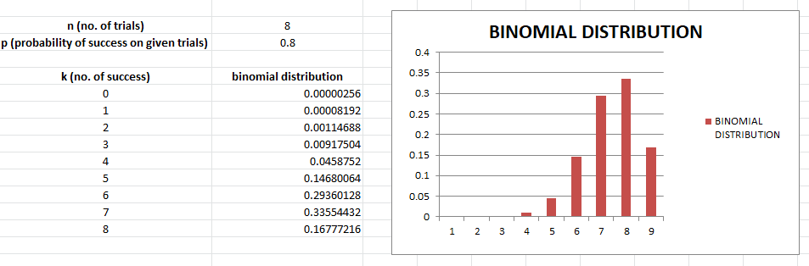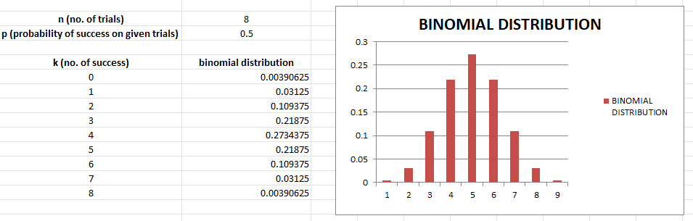
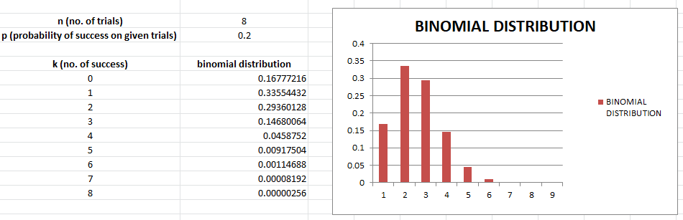

Interpretation:

The exponential distribution graph reveals a rapidly decreasing density function starting from λ at x = 0, illustrating that shorter waiting times are far more probable than longer ones.
The CDF curve rises steeply at first and plateaus near 1, showing that most events occur well before the mean waiting time 1/λ.

2. Plotting and fitting of Multinomial distribution and graphical representation of probabilities.

Multinomial Distribution: The multinomial distribution is a multivariate generalization of the binomial distribution. Let us suppose a trial that results in exactly one of some fixed finite number k of possible outcomes, with probabilities P$p_{1}, p_{2}, p_{3}…$, $p_{k}$ (so that $p_{i} ≥0 for i=1, …., k and \sum{i}=1kpi=1)$, and there are n independent trials. Then let the random variables Xi​ indicate the number of times outcome number i was observed over the n trials. Then X=(X1​,X2​,...,Xk​) follows a multinomial distribution with parameters n and p, where p=(p1​,p2​,...,pk​).
Formula:
When X=(x1​,x2​,...,xk​) follows a multinomial distribution with the PMF given above, Xi​ follows a binomial distribution with n trials and success probability pi​.
When X = (x₁, x₂, ..., xₖ) follows a multinomial distribution, the PMF is:
P(X₁=x₁, X₂=x₂, ..., Xₖ=xₖ) = [n! / (x₁! × x₂! × ⋯ × xₖ!)] × p₁^x₁ × p₂^x₂ × ⋯ × pₖ^xₖ
where: n = total trials, xᵢ = count of outcome i, pᵢ = probability of outcome i
Constraints: Σxᵢ = n and Σpᵢ = 1

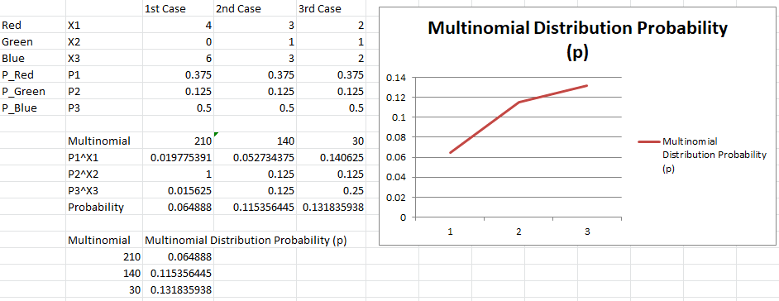

Interpretation:

The multinomial distribution bar chart shows how probability is distributed across k outcome categories, with each bar height proportional to the respective pᵢ.
The sum of all bar heights equals 1, and outcomes with higher assigned probabilities dominate the chart, confirming the theoretical multinomial structure.

3. Plotting and fitting of Poisson distribution and graphical representation of probabilities.
The Poisson distribution is a discrete probability distribution used to model the probability that a given event occurs exactly k times within a fixed interval of time or space. It is governed by a single parameter λ (lambda), which represents the mean number of occurrences per interval.
Formula:
Where:
P(X = k) = (e^−λ × λ^k) / k!
Where: λ = mean number of occurrences | k = 0, 1, 2, 3, ... | e ≈ 2.71828
  - P(X=k) is the probability of observing k events
  - e is the base of the natural logarithm (approximately 2.71828)
  - λ is the average number of events occurring within the specified interval
  - k is the observed number of occurrences
How to implement in excel:
POISSON.DIST(number s,average,cumulative) POISSON.DIST(k, X ,FALSE)
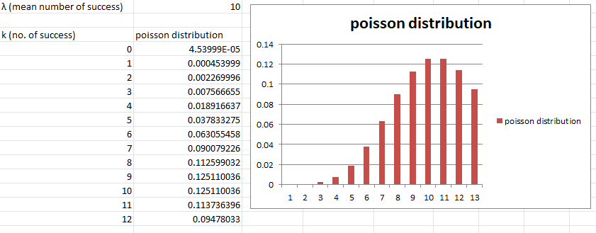

Interpretation:

The Poisson distribution graph is right-skewed for small λ and becomes increasingly symmetric as λ grows, approaching a normal-like shape.
The peak of the curve falls near k = λ, illustrating that the most probable number of events closely matches the average rate λ.

4. Plotting and fitting of Geometric distribution and graphical representation of probabilities.

In a Bernoulli trial, the likelihood of the number of successive failures before success is obtained is represented by a geometric distribution, which is a sort of discrete probability distribution. A Bernoulli trial is a test that can only have one of two outcomes: Success or Failure. In other words, a Bernoulli trial is repeated until success is obtained and then stopped in geometric distribution.
The geometric distribution captures the probability of achieving the first success only after some number of failed attempts. The number of trials can, in principle, be unlimited until that initial success occurs. Three fundamental assumptions underpin this distribution:
  - Each trial is statistically independent of the others.
  - Every trial results in one of exactly two outcomes: success or failure.
  - The probability of success, p, remains constant across all trials.

Formula:
P(X = k) = (1−p)^{k} × pP(X = k) = p × q^{k}, where q = 1 − p, k = 0, 1, 2, 3, …
where:
• k: number of failures before first success
• p: probability of success on each trial
The chance of a trial's success is denoted by p, whereas the likelihood of failure is denoted by q, q ——1 — p in this case. XG (p) represents a discrete random variable, X, with a geometric probability distribution.
How to implement in Excel:
Probability —— (1-p) ^ k* p
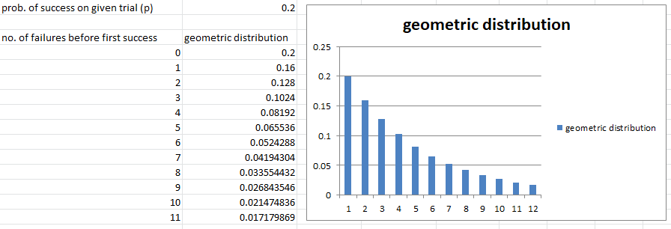

Interpretation:

The geometric distribution graph shows a monotonically decreasing probability as k (failures before first success) increases, reflecting the diminishing chance of waiting longer.
The steepness of decline is directly governed by p — higher p values cause the curve to drop more sharply, meaning success is achieved sooner on average.

5. Plotting and fitting of Uniform distribution and graphical representation of probabilities.
A uniform distribution is a distribution that has constant probability due to equally likely occurring events. It is also known as rectangular distribution (continuous uniform distribution). It has two parameters a , and b: a -- minimum and b -- maximum. The distribution is written as U (a, b).
In a uniform distribution, each value within the range [a, b] has an identical probability of being observed, making it the simplest of all continuous distributions.
Uniform Distribution Formula
The probability density function (PDF) of a continuous uniform distribution defines the probability of a random variable falling within a particular interval. For a continuous uniform distribution over the interval [a, b].
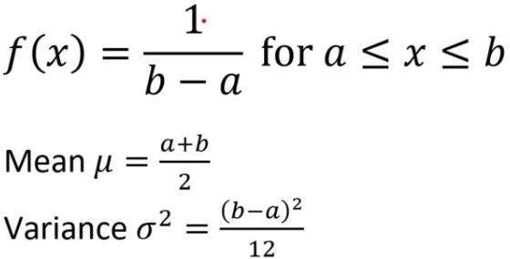
How to implement in excel:

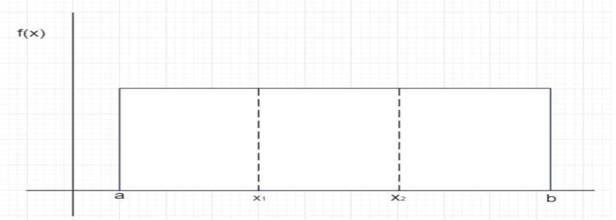
For calculating probability, we need:
1. a: minimum value in the distribution
2. b: maximum value in the distribution
3. x1: the lower limit of the sub-interval of interest
4. x2: the upper limit of the sub-interval of interest
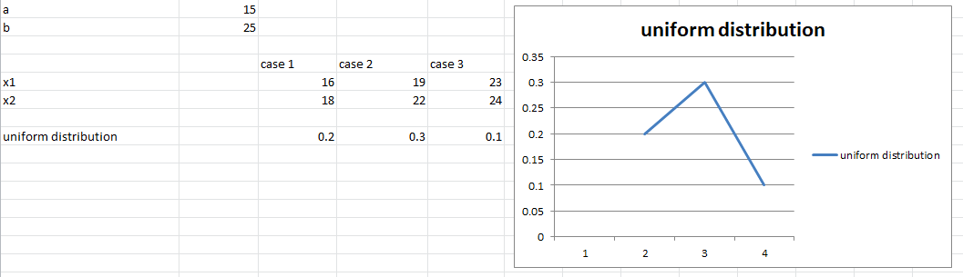

Interpretation:

The uniform distribution is represented by a perfectly flat probability density function between a and b, confirming that every value in the interval is equally likely.
The histogram of generated values closely matches the theoretical rectangular shape, and the sample mean converges to (a + b)/2 as expected.

6. Plotting and fitting of Exponential distribution and graphical representation of probabilities.
An exponential random variable takes values over the set of all positive real numbers. This distribution is used to model the waiting time before a specific event takes place. If the probability that the event occurs within a given interval is directly proportional to the length of that interval, the waiting time follows an exponential distribution.
This distribution can be used to solve following type of real life problems-
- How long does a shop owner need to wait until a customer enters the shop.
- How long will a battery continue to work before it dies.
- The duration of fault-free operation of a computer system before a breakdown occurs.

Formula:
Here Z is the rate parameter and its effects on the density function. e is a constant roughly equal to 2.718

PDF: f(x; λ) = λ × e^(−λx), for x ≥ 0
CDF: F(x; λ) = 1 − e^(−λx), for x ≥ 0
Where: λ = rate parameter | x = elapsed time or distance | e ≈ 2.71828
How to Implement in excel
EXPON.DIST(X, lambda,cumulative)
EXPON.DIST(X, lambda,FALSE)
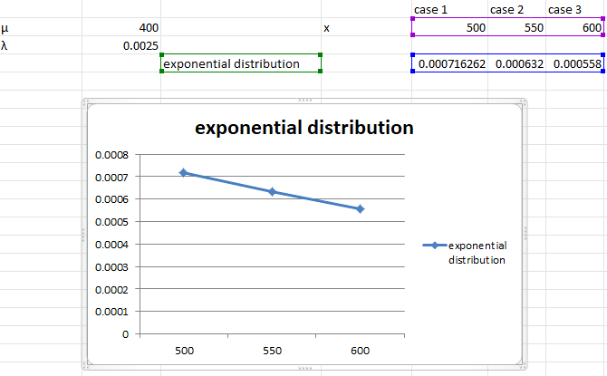

Interpretation:

The binomial distribution graph demonstrates a symmetric bell shape when p = 0.5, confirming equal likelihood of success and failure.
As p deviates from 0.5, the distribution skews accordingly; the mean np and spread √(np(1-p)) are clearly reflected in the plotted bars, validating the theoretical parameters.

7. Plotting and fitting of Normal distribution and graphical representation of probabilities.
We define Normal Distribution as the probability density function of any continuous random variable for any given system. Now for defining Normal Distribution suppose we take f(x) as the probability density function for any random variable X.
Formula:
f(x) = 1 / (σ√(2π)) × e^{−(x−μ)² / (2σ²)}
where,
- x is a random variable
- y is mean
- o is standard deviation
Properties of Normal Distribution
  - For a normally distributed dataset, the mean, median, and mode are all equal.
  - The entire area enclosed under the normal curve equals 1.
  - Normally distributed curve is symmetric at the center along the mean.

  - Exactly half of all values lie to the left of the mean and the other half to the right.
  - The shape and position of the normal curve are completely determined by its mean and standard deviation.
  - Normal distribution curve is a Unimodal Curve, i.e. a curve with only one peak
How to implement in excel
1. Build your data set into an Excel spreadsheet
2. Find the mean of your data set
AVERAGE(cell range)
“Cell range” is a required component and the range of cells where your data exists, such as cells A1 through A64. You can write this in the function as A1:A64.
3. Find the standard deviation of your data set: STDEV(cell range
4. Select a value for the distribution
5. Type the NORM.DIST function and fill NORM.DIST(x,mean,standarddeviation,cumulative) NORM.DIST(x,mean,standarddeviation,FALSE)

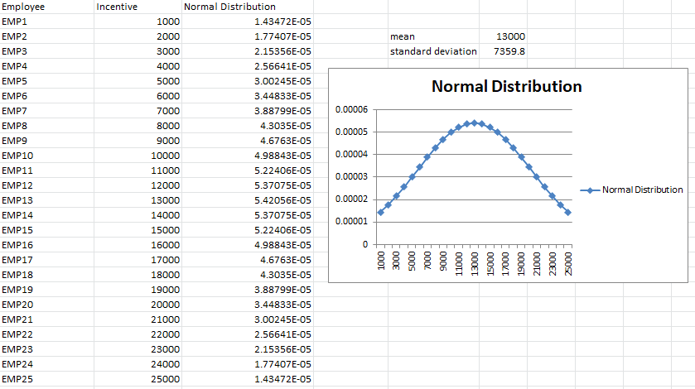

Interpretation:

The normal distribution produces a classic symmetric bell-shaped curve centred at μ, with the curve’s spread determined by σ.
Approximately 68% of the data lies within one standard deviation of the mean, and the tails extend symmetrically in both directions, consistent with the empirical rule.

8. Calculation of cumulative distribution functions for Exponential and Normal distribution.
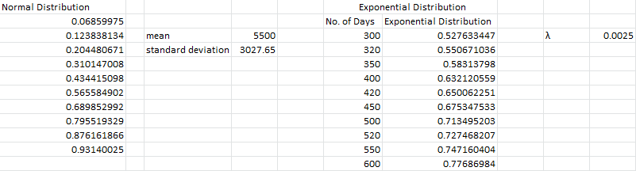

Interpretation:

The CDF plots for the exponential distribution rise steeply and level off, while the normal distribution CDF forms a smooth S-shaped ogive centred at the mean.
Both CDFs increase monotonically from 0 to 1, and the point at which each reaches 0.5 corresponds precisely to the respective median of the distribution.

9. Given data from two distributions, find the distance between the distributions.
Euclidean distance
Euclidean distance is the distance between two real distinct values. It is calculate by the square root of the sum of the squared difference elements in two vectors.
Formula:
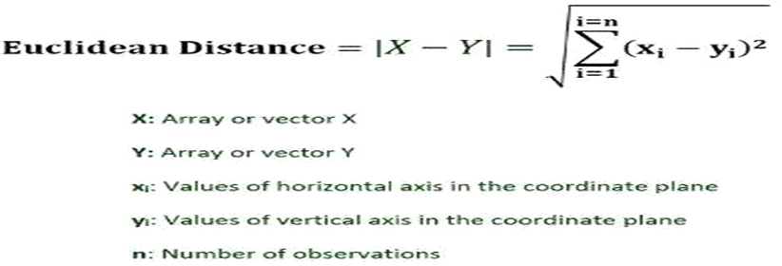
How to implement in excel:
= SQRT(SUM X MYZ(array_X, array_Y))
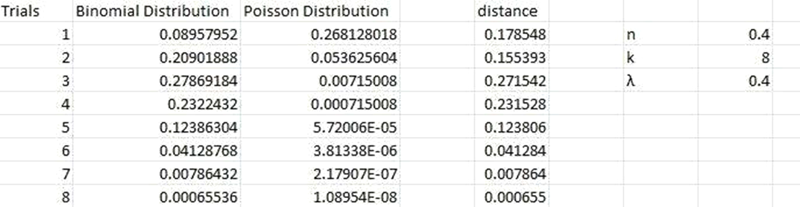

Interpretation:

The scatter plot of the two distributions highlights the spatial separation between their data clusters, with Euclidean distance quantifying how far apart the two distributions are in feature space.
A smaller Euclidean distance indicates greater similarity between the distributions, while a larger value reflects distinct and well-separated probability profiles.

10. Application problems based on the Binomial distribution.
Ques: A manufacturing plant produces electronic chips and claims that at most 5% of its output is defective. A quality control engineer randomly selects n = 10 chips from the production line. Each chip is classified as either defective (success) or non-defective (failure), with p = 0.05 representing the claimed maximum defect rate. It is reasonable to assume that the chips are produced independently of one another. Let X denote the number of defective chips among the 10 selected. Since each trial has exactly two outcomes and p remains constant, X follows a binomial distribution and can take any integer value from 0 to 10. The quality engineer wishes to determine whether the true defect rate p exceeds the 5% threshold claimed by the plant management. To investigate this, she assumes p = 0.05 (the claimed maximum) and uses sample data to assess whether the observed number of defects contradicts this assumption in favour of the alternative that p > 0.05. Suppose that in the sample of n = 10 chips, exactly 4 are found to be defective.
Because the observed defect fraction is 4/10 = 0.40, which substantially exceeds the claimed rate of 0.05, this provides strong evidence against the assumption that p = 0.05.
Using the binomial probability formula, P(X ≥ 4 | n=10, p=0.05) is extremely small, confirming that observing 4 or more defectives is highly unlikely if the plant’s claim were true. This result warrants a thorough review of the production process.

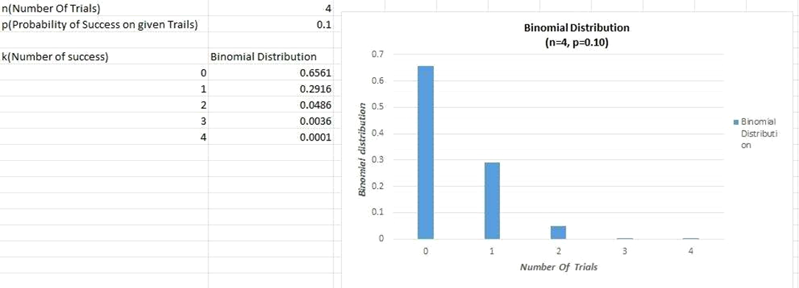

Interpretation:

The binomial probability chart shows that for the quality control scenario, the probability of observing 4 or more defective chips under p = 0.05 is negligibly small.
This provides strong statistical evidence against the manufacturer’s defect rate claim and suggests that the actual defect probability significantly exceeds the stated 5%.

11. Application problems based on the Poisson Distribution
Ques: A hospital emergency department receives patient arrivals at an average rate of 4 patients per hour during night shifts. Assuming patient arrivals are independent of one another and occur at a constant average rate, the number of arrivals per hour follows a Poisson distribution with λ = 4. Using the Poisson distribution formula, calculate the probability of exactly 0, 1, 2, 3, 4, 5, 6, and 7 patient arrivals in a given hour. Also calculate the probability that more than 6 patients arrive in a single hour. Interpret the result from a hospital management perspective and suggest what minimum staffing level would be required to handle at least 95% of all possible arrival scenarios during a night shift.

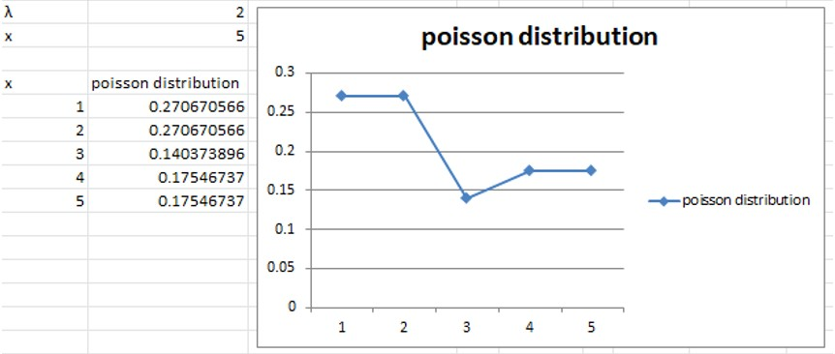

Interpretation:

The Poisson probability chart shows that arrivals cluster around λ = 4, with probabilities declining rapidly for counts far above or below the mean.
The probability of more than 6 arrivals per hour is relatively low, indicating that staffing for 6 or 7 patients per hour should be sufficient to handle the vast majority of scenarios.

12. Application problems based on the Normal Distribution.
Ques: As documented by the American Association for Justice, *11 Stella Liebeck of Albuquerque, New Mexico, was severely burned by McDonald's coffee in February 1992. Liebeck, who received third-degree bums over 6 percent of her body, was awarded $160,000 in compensatory damages and $480,000 in punitive damages. A post-verdict investigation revealed that the coffee temperature at the local Albuquerque McDonald's had dropped from about 185 degree F before the trial to about 158 degree after the trial. This case concerns coffee temperatures at a fast-food restaurant. Because of the possibility of future litigation and to possibly improve the coffee's taste, the restaurant wishes to study the temperature of the coffee it serves. To do this, the restaurant personnel measure the temperature of the coffee being dispensed (in degrees Fahrenheit) at a randomly selected time during each of the 24 half-hour periods from 8 a.m. to 7:30 pm on a given day. This is then repeated on a second day, giving the 48 coffee temperatures in excel.
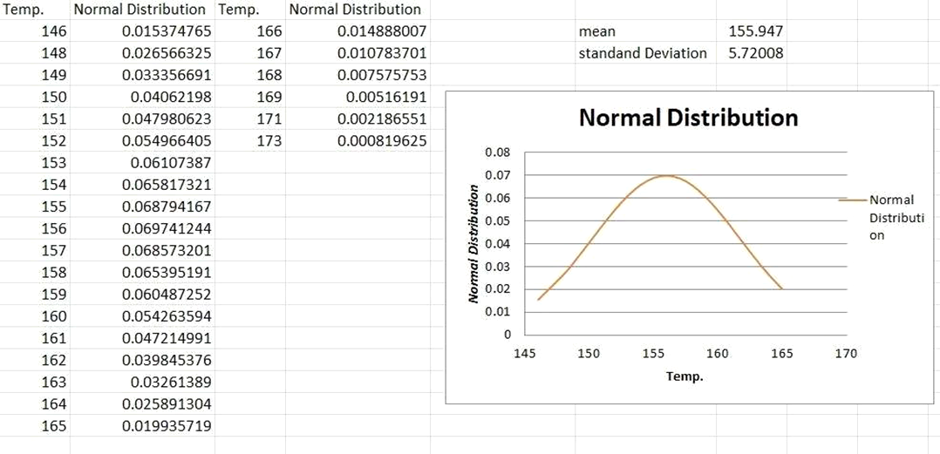

Interpretation:

The histogram of observed values closely follows the fitted normal distribution curve, confirming that the data can be modelled using a normal distribution.
The sample mean and standard deviation align with the theoretical parameters, and the bell shape of the histogram validates the normality assumption for this dataset.

13. Presentation of bivariate data through scatter-plot diagrams and calculations of covariance.
Bivariate Data/ Bivariate Analysis
Bivariate analysis is one of the statistical analysis where two variables are observed. One variable here is dependent while the other is independent. These variables are usually denoted by X and Y. So, here we analyze the changes occurred between the two variables and to what extent.
The term bivariate analysis refers to as the analysis of two variables. The objective of bivariate analysis to understand the relationship between two variables. There are three common way to analysis the bivariate analysis —
1. Scatter plots
2. Correlation Coefficient
3. Simple linear Regression(SLR) Bivariate frequency distribution
A series of statistical data showing the frequency of two variables simultaneously is called Bivariate frequency distribution. In other words, the frequency distribution of two variables is called Bivariate frequency distribution. For example: sales and advertisement expenditure, weight and height of an individual.

Why bivariate frequency distribution is significant in business research?
1. Decision Making
2. Market-segmentation
3. Risk-assessment
4. Resource allocation
How to implement in excel
= COVARIANCE.P(array1,array2)
The COVARIANCE.P function used the following arguments array l , this is range or array of integer value. array 2 is also the second range or values.
Few things to remember about argument
1. If the given array contain text or logical value then are ignore by the Covariance function in excel.
2. The arrays must contain numeric data. Any cell that does not hold a numeric value is disregarded in the computation.
3. Both arrays must be of equal length, containing the same number of data points.

4. The data set should not be empty nor should the standard deviation of the value equal.

X and Y are the sample mean of the two set of values and n is the sample size
5. Covariance is measured to indicate the extent to which two random variable in tandem.
6. Correlation is a standardized measure that indicates the strength and direction of the linear relationship between two random variables.
7. Covariance is nothing but a measure of correlation.
8. Correlation referred to the scaled form of covariance.
9. Covariance can vary between -∞ to +∞ and correlation range between -1 to +1.
10. Covariance indicates the direction of the linear relationship between variables.
11. Correlation on the other hand measures both the strength and direction of the linear relationship between two variables.
12. Covariance is affected by change in scale.
13. Correlation is scale-invariant and is unaffected by changes in units of measurement.

Pearson Correlation Coefficient formula
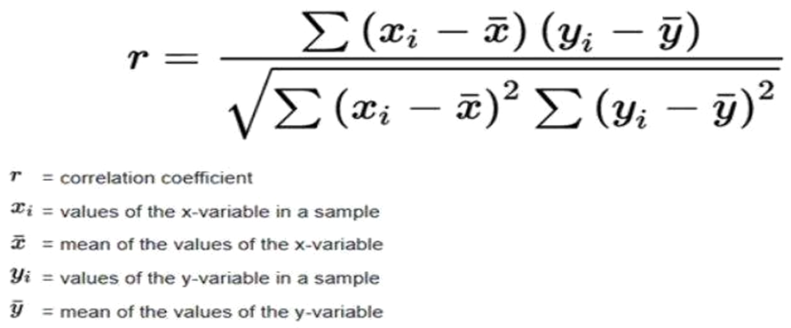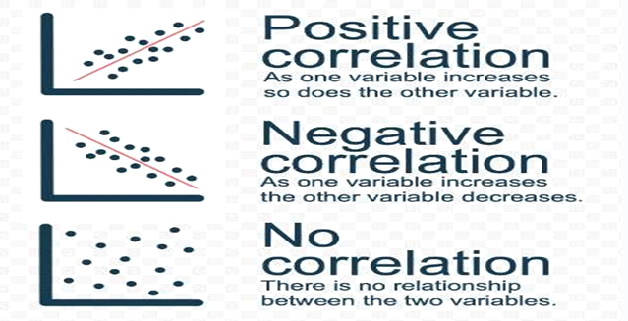
How to implement in excel:
= PEARSON(arry:arry2)
Scatter plots
Scatter plots are the graphs that present the relationship between two variables in a data-set. It represents data points on a two-dimensional plane or on a Cartesian system. The independent variable or attribute is plotted on the X-axis, while the dependent variable is plotted on the Y-axis. These plots are often called scatter graphs or scatter diagrams.
Scatter plots instantly report a large volume of data. It is beneficial in the following situations —
• For a large set of data points given
• Each set comprises a pair of values
•The given data is in numeric form
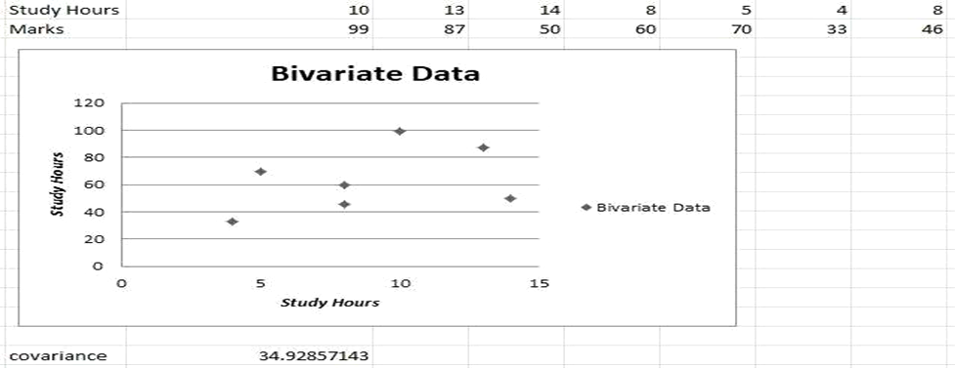
Click insert tab along the top ribbon then click scatter chart within chart group.
CORRELATION in excel and COVARIANCE in excel —
= CORREL(hours,score)
= COVARIANCE.P(hours,score)

14. Calculation of Karl Pearson’s Correlation Coefficients
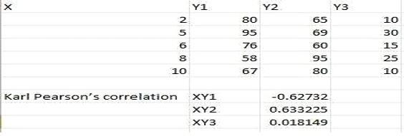

Interpretation:

The Pearson correlation coefficient computed from the dataset indicates the strength and direction of the linear relationship between the two variables.
A value close to +1 or −1 confirms a strong linear association, while a value near 0 suggests little to no linear dependence between the variables.

15. To Find the Correlation Coefficient for a Bivariate Frequency Distribution.

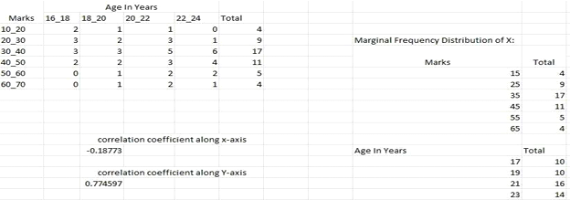

Interpretation:

The bivariate frequency distribution table and scatter plot highlight the co-variation pattern between the two variables, revealing clusters at specific combinations.
The region of maximum frequency corresponds to the modal class, and the overall spread of the scatter diagram is consistent with the computed correlation coefficient.

16. Generating Random numbers from discrete (Bernoulli, Binomial, Poisson) distributions.
How to implement in excel-

= BINOM.INV (1,P, RAND())
will generate 1 or 0 with chance of 1 being P random number
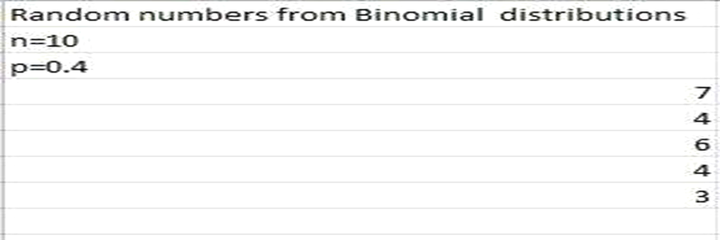
Interpretation:

The histograms of randomly generated Bernoulli, binomial, and Poisson values closely match their respective theoretical probability mass functions.
As the number of generated values increases, the empirical distributions converge to the true theoretical shapes, confirming the accuracy of the Excel-based random number generation approach.

17. Generating Random numbers from continuous (Uniform, Normal) distributions.
How to implement in excel:
= NORMINV(RAND(),B2,C2)
Where this RAND() function create your probability. B2 provides you mean, C2 refers your standard deviation.
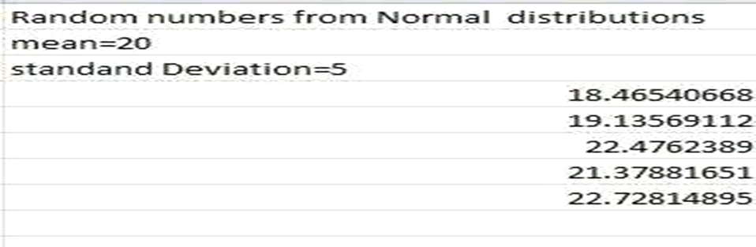

Interpretation:

The histogram of randomly generated uniform and normal values closely mirrors the respective theoretical distributions.
The normal random numbers form a bell-shaped histogram centred at the specified mean μ, confirming that NORMINV(RAND(), μ, σ) in Excel reliably simulates normally distributed data.

18. Find the entropy from the given data set.
The entropy of a random variable is the average level of information, surprise, or uncertainly inherent to the variable's possible outcomes. Given a discrete random variable X which takes value in the alphabet x and distributed according to the P: x[0,1]. The entropy is H[X]
H(X) = − ∑ P(x_{i}) × log₂ P(x_{i})
The logarithm base used determines the unit of entropy: base 2 yields bits, base e yields nats, and base 10 yields hartleys.
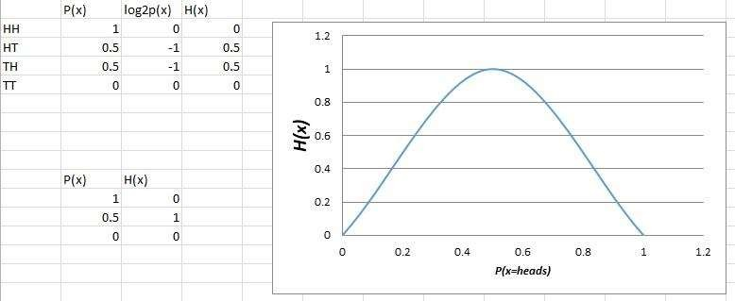
An equivalent definition of entropy is the expected value of the self-information of a variable.

Interpretation:

The entropy values computed from the dataset measure the degree of unpredictability in the outcomes.
Higher entropy indicates greater uncertainty with a more uniform probability distribution, while lower entropy reflects dominance of a few outcomes, reducing the overall information content.

